THE UNITED REPUBLIC OF TANZANIA

United Republic of Tanzania

UNITED NATIONS EDUCATIONAL SCIENTIFIC AND CULTURAL ORGANIZATION

GENERAL INFORMATION

INTERNATIONAL CONFERENCE

SAFEGUARGING AFRICAN WORLD HERITAGE AS A DRIVER OF SUSTAINABLE DEVELOPMENT

ARUSHA INTERNATIONAL CONFERENCE CENTRE
ARUSHA, TANZANIA
31 MAY- 3 JUNE 2016

Contents
1 PURPOSE 4
1.1 GOALS, TARGETS AND TOPICS 4
1.1.1 Goals of the Conference; 4
1.1.2 Targets 4
1.1.3 Topics/ Themes 4
2 MEETING ORGANIZERS 5
3 REGISTRATION 6
4 PROTOCOL 7
5 SECURITY 7
6 ACCOMODATION 8
7 PASSPORT, VISA AND OTHER TRAVEL INFORMATION 8
7.1 Passport Requirements 8
7.2 Visa Requirements 8
7.3 Travelling to Arusha 8
7.4 Medical Insurance 8
8 THE MEETING 9
8.1 Meeting Place 9
8.2 How to Get There 9
8.3 Reception Area for Participants 9
8.4 Meal Breaks 9
9 INFORMATION ON THE UNITED REPUBLIC OF TANZANIA 9
9.1 Currency and Exchange 11
9.2 Telephone Service 11
9.3 Driving in Tanzania 12
9.4 Postal Service 12
9.5 Smoking Regulations 12
9.6 Time Zone 12
9.7 Drinking Water 12
10 RECEPTION PROGRAM AND RELATED EVENTS 12
Excursions 12
11 MEDIA 13
11.1 Media Centre 13
11.2 Press Conference Room 13

PURPOSE
African Unit of the World Heritage Centre, in collaboration with the State party of The United Republic of Tanzania is organizing an International Conference on Safeguarding African World Heritage as a Driver of Sustainable Development, to be held at Arusha International Conference Center (AICC), in Arusha, Tanzania from 31st May to June 3rd,2016.
The conference aims to explore methods to strengthen the three dimensions of sustainable development, environmental sustainability, inclusive social and economic development while also fostering peace and security.

GOALS, TARGETS AND TOPICS

Goals of the Conference;
The conference will bring together and raise awareness among various stakeholders in African heritage on the timely topic of heritage conservation and sustainable development. The discussions will reflect the concern for “planet, people, prosperity and peace”, identified as areas of critical importance in the 2030 UN Agenda for Sustainable Development. The Conference’s principal goal is to address the issues, challenges, and major threats to the effective management and conservation of World Heritage in Africa.

Targets
A wide range of stakeholders in the fields of development and heritage conservation will participate in the Conference: private sector representatives, development banks and other development partners, universities, national environmental regulators, cultural heritage institutions, local authorities, African youth and women, heritage experts, site managers, academics, as well as members of the Advisory Bodies (ICOMOS, ICCROM, and IUCN) to the World Heritage Committee.

Topics/ Themes
Environmental Sustainability through the protection of biological and cultural diversity, the management of water resources, the strengthening of resilience to natural hazards and climate change.
Inclusive Social Development through mutual contribution to inclusion, equity, enhancing quality of life, well-being, relevance and quality of education, as well as the respect, protection and promotion of human rights.
Inclusive Economic Development through employment, income generation and livelihoods as well as the promotion of economic investment and quality tourism. The strengthening of capacities for innovation and local entrepreneurship will also be discussed.
Fostering Peace and Security; conflict prevention and resolution through traditional and other systems, heritage protection during conflict, post-conflict recovery, planning, and management.
Cultural heritage, through the promotion of cultural capital at heritage sites and beyond, can be a driver of sustainable development. The mobilization of cultural resources and the application of traditional management systems can be leveraged for poverty reduction and economic development for local communities.

MEETING ORGANIZERS
International Conference is organized by UNESCO, the Ngorongoro Conservation Area Authority and Ministry of Natural Resources and Tourism.
Contact Details
Addresses: UNESCO World Heritage Centre
7, Place de Fontenoy
75352 Paris CEDEX 07
France
Tel.: +33 (0)1 45 68 24 96
Fax: +33 (0)1 45 68 55 70
E-mail: wh-africa@unesco.org

UNESCO Office in Dar es Salaam
59 Mtwara Crescent, Oysterbay
P.O. Box 31473
Dar es-Salaam
United Republic of Tanzania
dar-es-salaam@unesco.org

Ngorongoro Conservation Area Authority
P.O. Box 1,
Ngorongoro Crater, Arusha -Tanzania
Tel: +255 27 253 7019
Fax: +255 27 253 7007
E-mail: joshuamwankunda@gmail.com

Ministry of Natural Resources and Tourism
Mpingo House,
40 Nyerere Road,
15472, Dar es Salaam, Tanzania
E-mail: evelyne_swai@yahoo.com

REGISTRATION

Please note that all requests to participate in the conference must be submitted online at the following address wh-africa@unesco.org. All representatives and those who wish to participate or attend the Conference are strongly advised to register as soon as possible and preferably before 20 May 2016. This is to allow the organizers sufficient time to process all the relevant information and to ensure that all the logistical arrangements are in place before the opening of the Conference
Should you require any assistance of encounter any problem with registration, please send an e-mail to wh-africa@unesco.org.

CONTACT PERSONS
Ms. Nguse Nyerere - Protocol, Visa, Security and Accreditation
Mobile: +255 684820950
Email: nguse2002@yahoo.com
OR
Ms. Evelyn Swai - Protocol, Visa, Security and Accreditation
Mobile: +255 685960071
Email: evelyn_swai@yahoo.com
Mr. Joshua Mwankunda – General National Coordination
Mobile: +255 755 159875
Email: joshuamwankunda@gmail.com
Ms. Nguse Nyerere – Immigration
Mobile: +255 684820950
Email: nguse2002@yahoo.com
Ms. Evelyn Swai – Customs and Excise
Mobile: +255 685960071
Email: evelyn_swai@yahoo.com
Mr. Joshua Mwankunda – Accommodation
Mobile: +255 755 159875
Email: joshuamwankunda@gmail.com

Mr. Erick Kajiru – Accomodation
Mobile: +255 754 017083
Email: erickesq@yahoo.com

Mr. Erick Kajiru – Transport and Logistics
Mobile: +255 754 017083
Email: erickesq@yahoo.com

PROTOCOL
The Conference organizer who is in charge of all matters relating to protocol and the reception of VIPs, Please contact:
Responsible: Mr. Joshua Mwankunda
Mobile: +255 755 159875
Email: joshuamwankunda@gmail.com

SECURITY
A special department will ensure the safety of all members of the Conference. The department responsible for the security during the conference Please contacts Mr… Erick Kajiru, mobile phone +255 017083

ACCOMODATION
Participants of the conference shall be responsible for the reservation of their hotel accommodation and all expenses incurred during their stay, including the hotel reservation. All participants must reserve their accommodation directly with the hotel. A credit card will be required for a reservation of hotel booking. Please not that a list of hotels with preferential rates is provided in Annex I. Booking may be done through the below link. These hotels are within walking distance from the Conference venue and Shuttles will only be available from these recommended hotels.

PASSPORT, VISA AND OTHER TRAVEL INFORMATION

Passport Requirements
All international visitors must have a passport that is valid for their stay in the United Republic of Tanzania.

Visa Requirements
For all enquiries concerning visas and other formalities required to enter the United Republic of Tanzania, participants are requested to contact directly the diplomatic mission of United Republic of Tanzania in their own country. Participants, whom diplomatic mission of United Republic of Tanzania is not in their countries, can get be able to get Visa on arrival. Visas-on-arrival will be available at Kilimanjaro International Airport for USD50 or USD100 for some nationalities.

Travelling to Arusha
The most common way to travel to Arusha is by plane. Arusha is served by two airports. Kilimanjaro International Airport (IATA: JRO) has regular flights to Amsterdam with KLM, and to Addis Ababa, Dar es Salaam, Zanzibar and Nairobi. Kilimanjaro Airport is approximately 60km (45min) from the city centre. A taxi ride costs USD50 but many airlines run a shuttle service for free or USD10. Arusha Municipal Airport (ARK) is on the outskirts of the city but only runs domestic flights, mostly to Zanzibar and Dar es Salaam, and charters. Arusha can be reached by express coach from Nairobi (Kenya, 6h, daily 08.00 and 14.00 from in front of Parkside Hotel costing USD35

Medical Insurance
A first-aid service and an ambulance shall be available to participants in case of need, near the place of the Conference but no other medical service shall be provided. Participants will be expected to cover the costs of any medical expenses incurred in the United Republic of Tanzania. Therefore, it is strongly recommended that participants to take out medical insurance in their home country that are accepted in the United Republic of Tanzania during their travel.

THE MEETING

Meeting Place
The international Conference of the Safeguarding African World Heritage as Driver of Sustainable Development will be held at the Arusha International Conference Centre in Arusha, Tanzania. It is the leading conference venue in East Africa.

How to Get There
The recommended hotels for participants to the Conference are not far from the Conference Center. The distant hotel is less than 10 minutes away by car. Moreover, comfortable shuttles will be provided for participants between recommended hotels and the conference.

Reception Area for Participants
As from 31st May, 2016, between 9:00 and 16:00 hrs., participants may follow the registration procedure and receive their badge at the registration desk situated in the Arusha International Conference Center, which is allocated a few meters away from the meeting room. Participants are encouraged to register before 1st June, 2016 which will be the opening day for the meeting. For participants who arrive at a later date, the registration desk will be open as from 7:30 am.

Meal Breaks
During the conference, coffee breaks and Lunch will be offered to the participants by organizers. Moreover, there are also numerous restaurants and cafes located in the town that can cater to various needs.

INFORMATION ON THE UNITED REPUBLIC OF TANZANIA
Tanzania officially the United Republic of Tanzania (Swahili: Jamhuri ya Muungano wa Tanzania), is a country in East Africa within the African Great Lakes region. It is bordered by Kenya and Uganda to the north; Rwanda, Burundi, and the Democratic Republic of the Congo to the west; Zambia, Malawi, and Mozambique to the south; and the Indian Ocean to the east. Kilimanjaro, Africa's highest mountain, is in northeastern Tanzania.
The name "Tanzania" was created as a clipped compound of the names of the two states that unified to create the country: Tanganyika and Zanzibar. The name "Tanganyika" is derived from the Swahili words tanga ("sail") and nyika ("uninhabited plain", "wilderness"), creating the phrase "sail in the wilderness". It is sometimes understood as a reference to Lake Tanganyika. The name of Zanzibar comes from "zinji", the name for a local people (said to mean "black"), and the Arabic word "barr", which means coast or shore.
At 947,303 square kilometers (365,756 sq mi), Tanzania is the 13th largest country in Africa and the 31st largest in the world, ranked between the larger Egypt and smaller Nigeria. Tanzania is mountainous and densely forested in the northeast, where Mount Kilimanjaro is located. Three of Africa's Great Lakes are partly within Tanzania. To the north and west lies Lake Victoria, Africa's largest lake, and Lake Tanganyika, the continent's deepest lake, known for its unique species of fish. To the southwest lies Lake Nyasa. Central Tanzania is a large plateau, with plains and arable land. The eastern shore is hot and humid, with the Zanzibar Archipelago just offshore.
9.1: Population
Tanzania's population of 51.82 million (2014) is diverse, composed of several ethnic, linguistic, and religious groups. Tanzania is a presidential constitutional republic, and since 1996, its official capital has been Dodoma, where the President's Office, the National Assembly, and some government ministries are located. Dar es Salaam, the former capital, retains most government offices and is the country's largest city, principal port, and leading commercial Centre.
9.2: Climate
Climate varies greatly within Tanzania. In the highlands, temperatures range between 10 and 20 °C (50 and 68 °F) during cold and hot seasons respectively. The rest of the country has temperatures rarely falling lower than 20 °C (68 °F). The hottest period extends between November and February (25–31 °C or 77.0–87.8 °F) while the coldest period occurs between May and August (15–20 °C or 59–68 °F). Annual temperature is 20 °C (68.0 °F). The climate is cool in high mountainous regions.
Nevertheless, in Arusha most rainfall (rainy season) is seen in March, April, November and December while dry periods are in June, July, August, September and October.On average, the warmest month is February and the coolest month is July. April and August are the wettest driest month respectively.
Tanzania has two major rainfall regimes: one is uni-modal (October–April) and the other is bi-modal (October–December and March–May). The former is experienced in southern, central, and western parts of the country, and the latter is found in the north from Lake Victoria extending east to the coast. The bi-modal regime is caused by the seasonal migration of the Intertropical Convergence Zone.
9.3: Introduction to Arusha
Arusha is a city in northern Tanzania and the capital of the Arusha Region, with a population of 416,442 plus 323,198 in the surrounding Arusha District (2012 census). Arusha, also known as "A" Town by the locals, is located below Mount Meru on the eastern edge of the eastern branch of the Great Rift Valley, Arusha has a temperate climate. The city is close to the Serengeti National Park, the Ngorongoro Conservation Area, Lake Manyara National Park, Olduvai Gorge, Tarangire National Park, Mount Kilimanjaro, and Arusha National Park on Mount Meru.
Arusha is a major international diplomatic hub. The city hosts and is regarded as the de facto capital of the East African Community. Since 1994, the city has also hosted the International Criminal Tribunal for Rwanda. It is a multicultural city with a majority Tanzanian population.
9.4: Local Transportation and Transfers to the Meeting Place
Most of the hotels are located close to the International Conference Centre (AICC). Shuttle buses will be provided by Organizers and you may also use taxi services or car rental services that can be organized by hotels.

Currency and Exchange
Shilling is the United Republic of Tanzania currency which is used in the country. Bank notes of Tanzania Shilling exist are 500, 1000, 2000, 5000 and 10000 but US dollars are accepted everywhere. The exchange rate in relation to the euro and US dollar fluctuate slightly, but are roughly 1 EUR =2500 TSH and 1 USD= 2200 TSH. The dollar is the most common currency used by foreigners. Money may be exchanged in all foreign exchange offices or banks, which are widespread in the city Centre. A large number of ATMs are available 24hrs.

Telephone Service
To make a telephone call from United Republic of the Tanzania using a land line phone dial: 00 then country code, then the city code and lastly the telephone number of the person dialed.
To make a telephone call to Tanzania from a foreign country using a cell phone, dial: + 255 then the country code, then telephone number of the person.
For local calls, dial the telephone number preceded by 0 whether it is a mobile or landline.

Driving in Tanzania
In Tanzania, driving is on the left-hand side of the road. Cars are equipped with manual or automatic gear charge. Drivers and all passengers must wear a seat belt. The use of a mobile telephone while driving is against the law while alcoholic drinks are strictly forbidden for the driver of the car. It is not expensive to rent a car, but it is recommended to hire a driver for convenience and safety reasons, traffic can be hectic during rush hours.

Postal Service
Post offices in United Republic of Tanzania are generally open from 8:00 to 15:30. The Central Post Office is situated in the city Centre at Clock Tower. A mailbox is also located at the AICC with official stamping available.

Smoking Regulations
In United Republic of Tanzania, it is strictly forbidden to smoke in public areas, places and in the buses. However, some hotels and restaurants have a designated area for smokers or smoking room. The availability of such rooms should be verified with the hotel.

Time Zone
Arusha is 3 hours ahead of Greenwich Mean Time (GMT +3).

Drinking Water
It is not recommended to drink tap water. Bottles of mineral water are widely available in shops and hotels at a reasonable price.

RECEPTION PROGRAM AND RELATED EVENTS

Excursions
Arusha is the hub for the Northern tourist circuit. Serengeti, Ngorongoro Crater, Lake Manyara, Tarangire and Arusha National Park are recommended areas to be toured by the participants. Also, the excursions can involve visiting Olduvai Gorge and Laetoli Footprint sites which provides the evidence of early human existence in Africa. However, the participants are responsible to cover the costs of these excursions, it is highly recommended to use official Tour operators for excursion. Official Tour Operators will be made available at the Conference area

MEDIA

Media Centre
A Media Centre will be made available to journalists covering the international conference. It will be used as a work station and be equipped with computer facilities and WIFI connection. Journalists wishing to organize interviews with members are required to submit their requests to the Press Centre. Eventual changes in the program will be posted in the Press Centre.

Press Conference Room
Press conferences will take place in a designated area for accredited media in the conference Centre. The program of events planned for the media will be provided at the time of registration.

ANNEX: RECOMMENDED HOTELS
Recommended Hotels have capacity to accommodate all delegates at the negotiated price and are within walking distance to the Conference Area. ( if interested in these hotels you cn register your name through email: joshuamwankunda@gmail.com copied to erickesq@yahoo.com

PALACE HOTEL –ARUSHA
P.O. Box 372, Arusha, Tanzania
Tel +255 27554 5800
Email: marketing @palacehotelarusha.com
www.palacehotelarusha.com

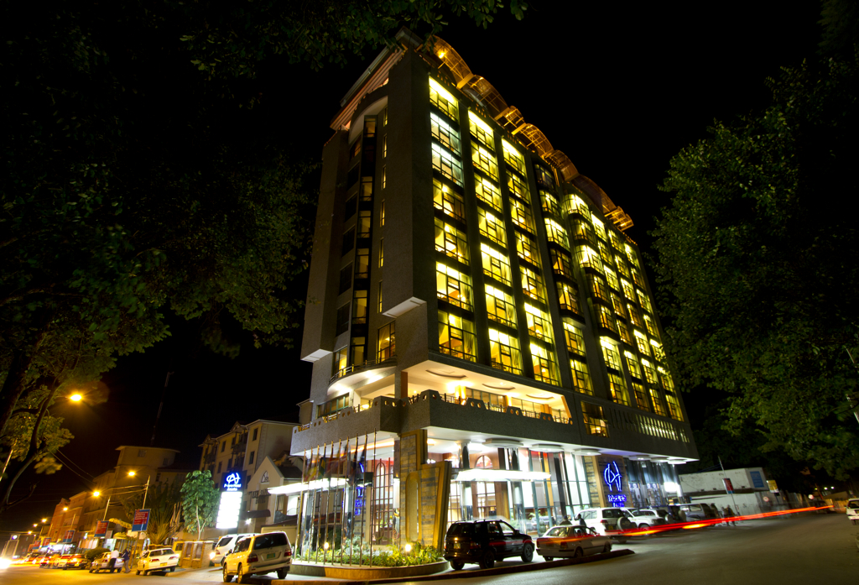

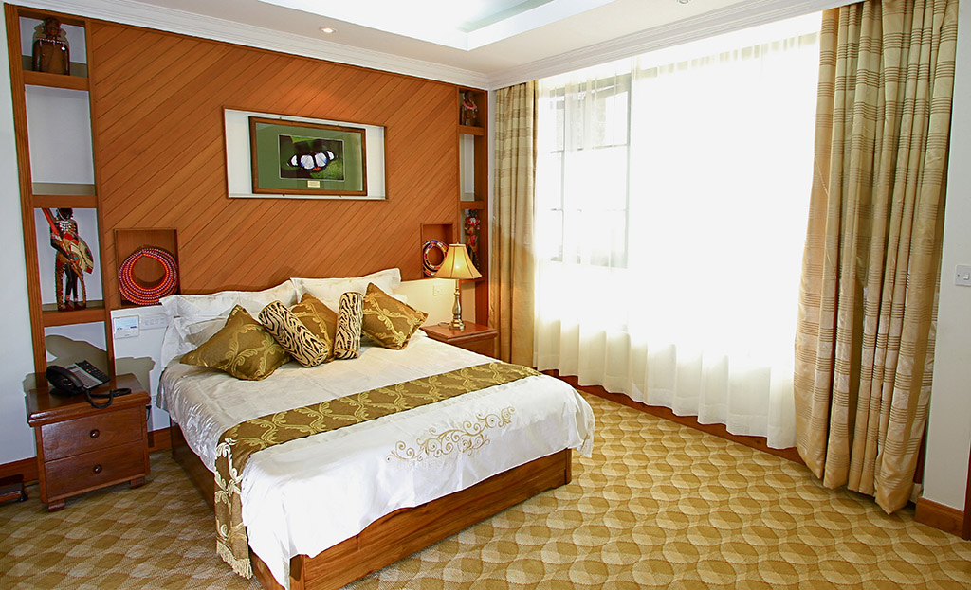

Palace Hotel is just 500m from the Conference Center

NEW SAFARI HOTEL
P.O.BOX 303, Arusha Tanzania
TEL + 255 27 2503261/2503262
Fax + 255 27 2548318
Email: newsafarihotel@habari.co.tz

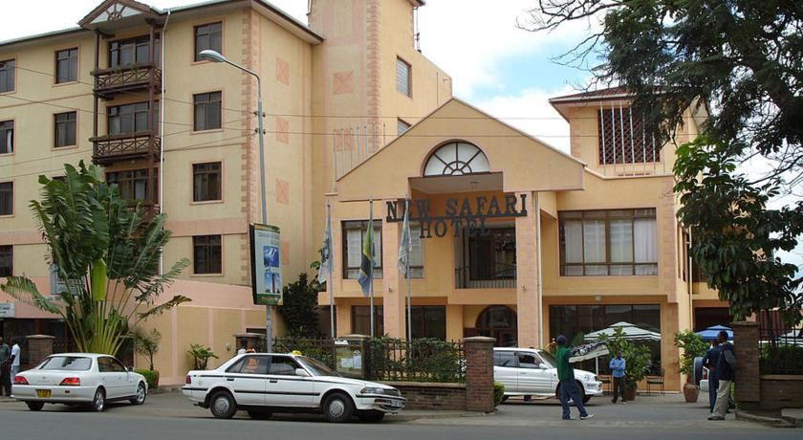
New safari hotel is 500m from the Conference center

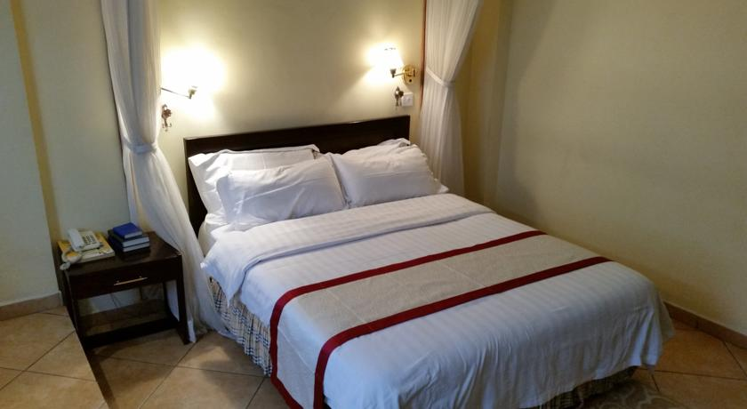

OTHER HOTELS
There are plenty of good hotels/BB and Lodges located at Arusha City with travel distances ranging from 10km – 30 Km. – you can google or search through trip adviser and other hotel search engines/ websites

